Injectable Adult Stem Cells as a Novel Therapeutic Platform for Anterior and Posterior Spinal Fusion

¹Dima Sheyn, ¹Gadi Pelled, ¹Zulma Gazit, ²Christopher J. Zarembinski, ³Neel Anand, ³Patrick J. Johnson, and ¹Dan Gazit

¹Skeletal Biotech Laboratory, Hebrew University-Hadassah Medical Campus, Jerusalem, Israel
²The Pain Center, Cedars Sinai Medical Center, Los Angeles, CA
³Institute for Spinal Disorders, Cedars Sinai Medical Center, Los Angeles, CA

Introduction: Spinal fusion has become a popular surgical technique used to provide segmental fixation of the spine. We have previously shown that stem cell-based therapy using safe, non-virally genetically engineered adult stem cells (ASCs), that express bone morphogenetic protein (BMP) genes, could induce bone formation in vivo. Therefore, we hypothesized that primary adult stem cells, nucleofected with human BMP-6 gene, directly injected into the intervertebral disc (IVD) or its vicinity could induce posterior or anterior spinal fusion.
Methods: Porcine ASCs were isolated from freshly harvested adipose tissue. Overexpression of hBMP-6 was achieved using nucleofection, an electroporation-based technique (Fig. 1). Engineered ASCs were labelled with luciferase or GFP marker genes prior to injection. 24 hours post nucleofection the cells were injected into the caudal intervertebral disc of immunodeficient rats or into the lumbar paraspinal muscle of immunodeficient mice. Spinal fusion was monitored using real time, non-invasive micro-CT, in vivo. Cell survival was monitored on tissue level using a non-invasive, quantitative, bioluminescence imaging system (Fig. 2A), and on cellular level using a novel in vivo fibered confocal microscope (Fig. 2B).
Results: ASCs survived at least 2 weeks in vivo as demonstrated by quantitative bioluminescence and fluorescence imaging. Quantitative uCT analyses demonstrated extensive bone formation in the paraspinal sites (Fig. 2E) and in the disc region, leading to interbody fusion (Fig. 2C).
Conclusions: We report here a novel, safe, injectable and well-monitored system for the induction of posterior and anterior spinal fusion using engineered primary ASCs. These results may provide a novel biological therapeutic platform for spinal fusion.

At the completion of the session or demonstration, participants should be able to understand how stem cell-based injectable systems can be used for the treatment of spinal disorders and the use of cutting edge imaging systems in stem cell therapy approaches.

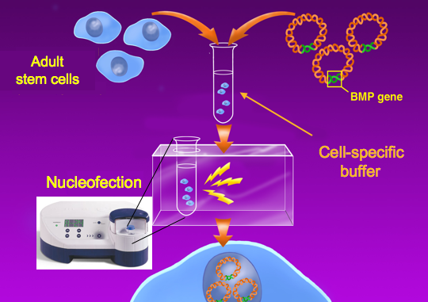
Fig.1 Nucleofection of adult stem cells ex vivo. Porcine adipose tissue-derived ASCs, nucleofected with hBMP-6 encoding plasmid DNA.
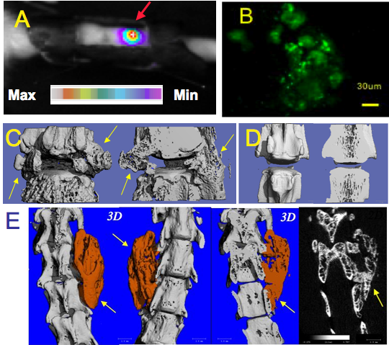

Fig. 2 Anterior and Posterior stem cell-based spinal fusion. In vivo, non-invasive, bioluminescence imaging of the injected cells in the IVD (A). In vivo fibered confocal microscopy imaging of GFP labeled cells in the IVD (B). Micro-CT scans demonstrating interbody fusion evaluation following the injection of engineered ASCs(C). No fusion achieved with non-engineered ASCs (D). Micro-CT scans of posterior spinal fusion (E). Arrows indicate new bone formation.

