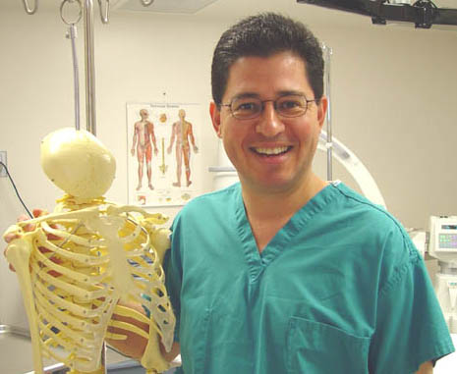
CHRISTOPHER J. ZAREMBINSKI, M.D.

Interventional Pain Management


Dr. Zarembinski offers comprehensive diagnostic, therapeutic and management services for chronic, acute, and cancer pain. Treatment is provided on an outpatient basis with a structured, time-limited program specific to the patient’s individual needs.

Interventional pain management involves specialized procedures to treat and manage pain. These might include an injection of a local anesthetic or steroid around nerves, joints, or muscles; spinal cord stimulation; insertion of a drug delivery system; or radiofrequency ablation to stop pain for an extended period of time.

Most Commonly Treated Conditions

Patients requiring specific pain management procedures include those who experience pain as a result of surgery, trauma, low back degeneration, disc disease of the neck, muscle spasm, facial injury, and migraine headache. Pain treatment for chronic regional pain syndromes and post-herpetic neuralgia is also available. Joint pain is a growing area for precision-guided techniques.

Interventional Pain Goals

While emphasizing patient safety in a gentle environment, the goals of interventional pain management include:

Decrease frequency and intensity of pain.
Increase activities of daily living.
Enhance coping skills.
Resolve sleep disturbances.
Lower narcotics and other pain medications to the lowest effective doses.

Invasive Treatments

State-of-the-art fluoroscopically equipped interventional pain management suite is used to provide access for patients in an efficient manner. Available procedures include:

Epidural injections (cervical, thoracic, lumbar, and caudal).
Selective nerve root blocks (cervical, thoracic, lumbar, and sacral).
Facet injections and medial branch blocks (cervical, thoracic, and lumbar).
Sympathetic blocks (stellate ganglion, thoracic, and lumbar).
Discography (provocative with pressure manometry, and functional anesthetic with catheterization).
Peripheral nerve blocks (head, neck, thoracic, extremities).
Radiofrequency ablation for longer term relief of neck and back pain.
Spinal cord stimulation for persistent back and extremity pain.
Sphenopalatine ganglion block to aid diagnostically for facial pain treatment options.
Gamma knife for longer term relief of facial pain.
Ultrasound guided botox for muscle spasticity.
Knee, hip, shoulder joint injections using precision-guided fluoroscopy.

For More Information

Referrals are welcomed from physicians, worker’s compensation adjusters, industrial carriers, healthcare organizations, and fellow patients. For more information on Interventional Pain Management, or to make an appointment, please contact Dr. Zarembinski at:

The Pain Center
444 S. San Vicente Blvd.
Suite 1101
Los Angeles, CA 90048
Phone: (310) 423-9613
Phone: (213) 252-8227
Fax: (310) 423-9610
E-mail: jointvitality@yahoo.com
Web: www.drzarembinski.com
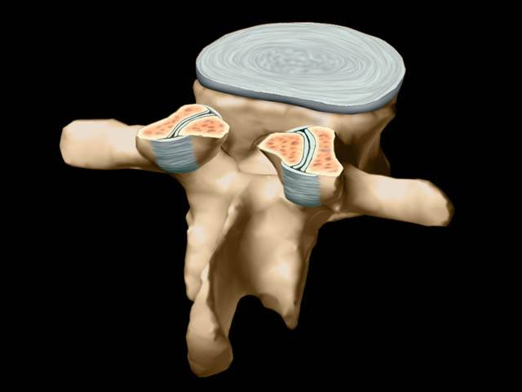
Web: www.jointvitality.com

